

|  |
| --- |
| **Activity 1.2.5 Mechanical System Efficiency** |

Equipment

* Winch system and materials from Activity 1.2.5a Mechanical Efficiency Winch
* Permanent marker
* Multimeter
* Stopwatch or other device for timing seconds

Procedure

In this activity you will investigate an energy conversion system designed to change electrical energy into mechanical energy. You will determine the efficiency of the system by collecting data regarding power input and output. Remember units and precision when recording data.

Create a Winch System to Lift a Weight

1. Be sure that all connections and parts are functioning correctly. Make necessary corrections.
2. Choose an approximately 100 gram weight to attach to the winch. Record the exact weight.

Weight to be lifted = __100g (0.0)

1. Attach the weight. Place the device so that the weight freely hangs from the edge of a table.
2. Completely unwind the winch cable so that the weight freely hangs from the edge of the table. Measure 15 cm up from the end of the paperclip and mark the winch cable using permanent marker. This will become your winch stop point. Measure 30cm up from your 15cm mark and mark the winch cable using permanent marker. This will become your winch start point.

Length to be lifted (distance between start and stop point) = __10 cm (0.0)

1. Use the mini switch to operate your winch. Wind the winch cable until the start mark reaches the 90mm metal axle support arm.
2. Set your multimeter to measure voltage. Connect the multimeter test leads to the S-motor terminals.

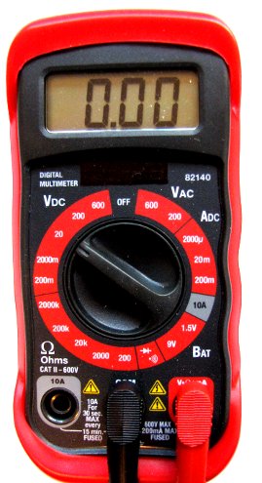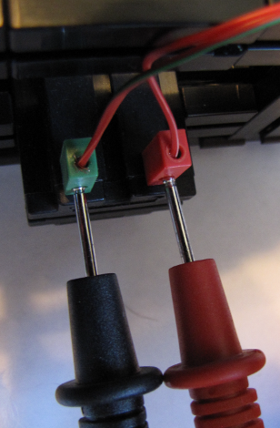

1. With the test leads from the multimeter connected at the S-motor, press the mini switch to activate the winch. Release the mini switch once the stop mark on the winch cable reaches the 90mm metal axle support arm. As the winch lifts the 100g weight, record the average voltage reading from the multimeter.

Voltage = ______9.15 V (0.0)

1. Unwind the winch cable so that the start mark on the winch cable is lined up with the 90mm axle support.
2. Set your multimeter to measure current. To measure current you must break the circuit so that current flows through the test leads. Disconnect the two red flat plugs and insert the multimeter test leads into each plug.

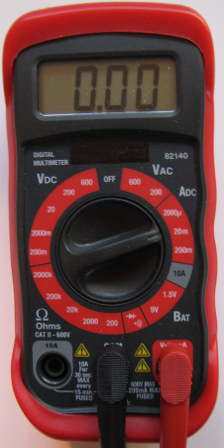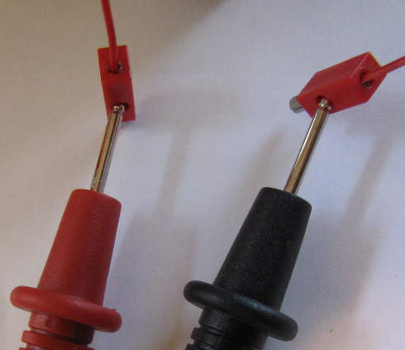

1. With the test leads from the multimeter connected at the red flat plugs, press the mini switch to activate the winch. Release the mini switch once the stop mark on the winch cable reaches the 90mm metal axle support arm. As the winch lifts the 100g weight, record the average current reading from the multimeter.

Current = ___125 mA (0.0)

1. Disconnect the test leads from the red flat plugs and reconnect the red flat plugs.
2. Unwind the winch cable so that the start mark on the winch cable is lined up with the 90mm axle support.
3. Use a stopwatch to measure the time it takes for the winch system to lift the 100g weight from the start to stop mark. Record the amount of time in seconds.

Seconds = ______7.8 s (0.0)

1. Convert the following values.

cm lifted = ___0.1 meters (m) (0.000)

grams lifted = ___1 Newton (N) (0.000)

mA of current = __0.125 Amps(A) (0.000)

Work involves the amount of force (F) exerted over a specific distance (D). Work is not related to time. It might take more time to make a trip in an old biplane than it would in a jet, but both aircraft are performing the same amount of work. Use the following formula to determine how many joules (J) of work it took to lift the weight in the system. As you carry your units through to the solution, change the final answer from Nm to J.

1. Determine the work done by the winch system.

|  |  |  |
| --- | --- | --- |
| Formula | Substitute / Solve | Final Answer (0.000) |
| Work = F x D  = N x m | Work= 1*0.1=0.1 | 0.100j |

Power involves time, force, and distance. In the previous example, both planes completed the same amount of work because they covered the same amount of distance. Time was not a factor. To cover the distance faster, the jet plane uses more power. Use the formula below to calculate the output power of the system in watts (W). As you carry your units through to the solution, change the final answer from J/s to W.

1. Determine the output power of the system.

|  |  |  |
| --- | --- | --- |
| Formula | Substitute / Solve | Final Answer (0.000) |
|  | Pout= .1/7.8=0.0128 | 0.0128w |

1. To calculate watt power of an electrical system, multiply the current times voltage. Substitute and solve to discover how many watts were put into your system. You do not need to show the relationship of units to solve the problem, but be sure to label your final answer as watts.

|  |  |  |
| --- | --- | --- |
| Formula | Substitute / Solve | Final Answer(0.000) |
| Pin = I x V | Pin= 0.125*9.15=1.14375 | 1.14375w |

1. In order to compare the energy input versus the output, the efficiency of the system must be determined. Use the given formula to calculate efficiency.

|  |  |  |
| --- | --- | --- |
| Formula | Substitute / Solve | Final Answer (0.0) |
|  | %Efficiency =(0.0128/1.14375)100= | 1.119% |

Conclusion

1. List and describe three factors that reduced efficiency in the winch system.
   * Friction-in the gears and in between the string and axle.
   * The winch needed to pull the string and paper clip as well as the 100g weight.
   * The string didn’t grip the axle as well as it should have, this made the weight take longer to lift up 10 cm then it should have.
2. Describe one strategy for making the system even more efficient.

To make the machine more efficient you could drill a hole through the axle and tie the string through it so it can’t slip while pulling the 100g weight up.

1. Explain two or more reasons why automotive engineers are concerned with eliminating inefficiency from vehicles.

If a vehicle is inefficient, it uses more energy to run. Gasoline is quickly drying up as an energy source for automobiles. The more efficient automotive engineers can make a car, the less gas it will use. The less gas used gives people more time to find and alternate energy source for gasoline.